# ASSIGNMENT– 1

**PLASMA DONOR APPLICATION**

**app.py**

fromflaskimportFlask,render_template

app =Flask( name )@app.route("/")

defhome():

returnrender_template("home.html")

@app.route("/about")defabout():

returnrender_template("about.html")

@app.route("/sign_up")defsign_up():

returnrender_template("sign_up.html")

@app.route("/sign_in")defsign_in():

returnrender_template("sign_in.html")

if name ==" main ":app.run()

## base.html

<!doctypehtml>

<htmllang="en">

<head>

<!--Required metatags-->

<metacharset="utf-8">

<meta name="viewport" content="width=device-width, initial-scale=1,shrink-to-fit=no">

<!--BootstrapCSS-->

<link rel="stylesheet"href="https://stackpath.bootstrapcdn.com/bootstrap/4.3.1/css/bootstrap.min.css" integrity="sha384-ggOyR0iXCbMQv3Xipma34MD+dH/1fQ784/j6cY/iJTQUOhcWr7x9JvoRxT2 MZw1T"crossorigin="anonymous">

{%blockhead%}{%endblock%}

</head>

<body>

<navclass="navbarnavbar-expand-lgbg-light">

<divclass="container-fluid">

<aclass="navbar-brand"href="#">Navbar</a>

<button class="navbar-toggler" type="button" data-bs-toggle="collapse"data-bs-target="#navbarNav" aria-controls="navbarNav" aria-expanded="false"aria-label="Togglenavigation">

<spanclass="navbar-toggler-icon"></span>

</button>

<divclass="collapsenavbar-collapse"id="navbarNav">

<ulclass="navbar-nav">

<li class="nav-item">

<aclass="nav-linkactive"aria-current="page"href="/">Home</a>

</li>

<li class="nav-item">

<aclass="nav-link"href="/about">About</a>

</li>

<li class="nav-item">

<aclass="nav-link"href="/sign_up">SingUp</a>

</li>

<li class="nav-item">

<aclass="nav-link"href="/sign_in">SignIn</a>

</li>

</ul>

</div>

</div>

</nav>

<!--OptionalJavaScript -->

<!--jQueryfirst,thenPopper.js,thenBootstrapJS-->

<script src="https://code.jquery.com/jquery-3.3.1.slim.min.js"integrity="sha384-q8i/X+965DzO0rT7abK41JStQIAqVgRVzpbzo5smXKp4YfRvH+8abtTE1Pi6jizo"crossorigin="anonymous"></script>

<scriptsrc="https://cdnjs.cloudflare.com/ajax/libs/popper.js/1.14.7/umd/popper.min.js" integrity="sha384-UO2eT0CpHqdSJQ6hJty5KVphtPhzWj9WO1clHTMGa3JDZwrnQq4sF86dIHNDz0W1"crossorigin="anonymous"></script>

<scriptsrc="https://stackpath.bootstrapcdn.com/bootstrap/4.3.1/js/bootstrap.min.js" integrity="sha384-

JjSmVgyd0p3pXB1rRibZUAYoIIy6OrQ6VrjIEaFf/nJGzIxFDsf4x0xIM+B07jRM"crossorigin="anonymous"></script>

{%block body%}{%endblock%}

</body>

</html>

## home.html

{%extends'base.html'%}

{%blockhead%}

<title>Home</title>

{%endblock%}

{%blockbody%}]

<h4>ThisisHomePage</h4>

{%endblock%}

## Output:

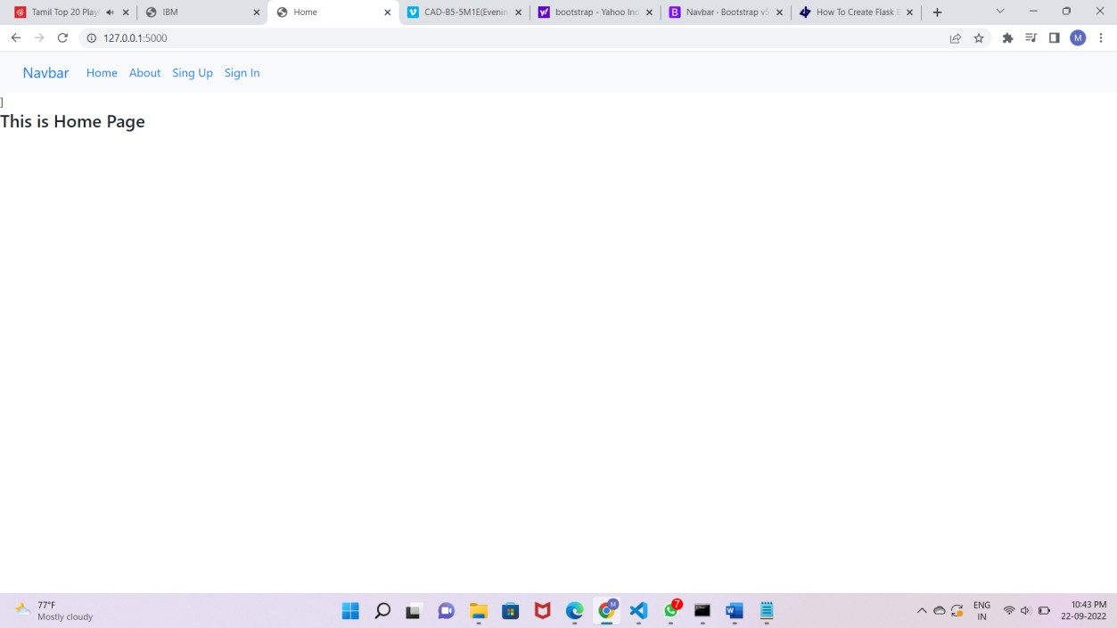

**About.html**

{%extends'base.html'%}

{%blockhead%}

<title>About</title>

{%endblock%}

{%blockbody%}

<h4>ThisisAboutPage</h4>

{%endblock%}

## Output:

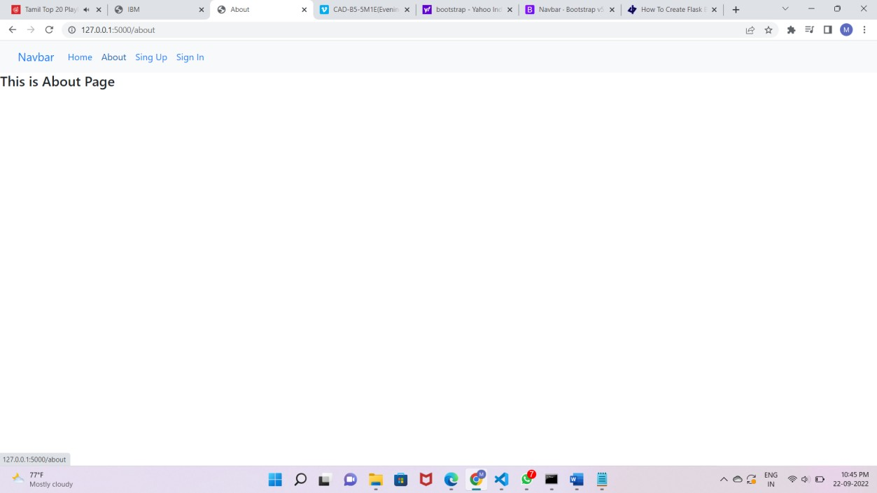

**sign_up.html:**

{%extends'base.html'%}

{%blockhead%}

<title>SignUp</title>

{%endblock%}

{%blockbody%}

<center><h2>SignUpForm</h2></center>

<form>

<divclass="mb-3">

<labelfor="name"class="form-label">Name</label>

<inputtype="email"class="form-control"id="name">

</div>

<divclass="mb-3">

<labelfor="email"class="form-label">Emailaddress</label>

<inputtype="email"class="form-control"id="email">

</div>

<divclass="mb-3">

<labelfor="pwd"class="form-label">Password</label>

<inputtype="password"class="form-control"id="pwd">

</div>

<divclass="mb-3">

<labelfor="cpwd"class="form-label">Emailaddress</label>

<inputtype="password"class="form-control"id="cpwd">

</div>

<center><button type="submit" class="btn btn-primary">SignUp</button></center>

</form>

{%endblock%}

## Output:

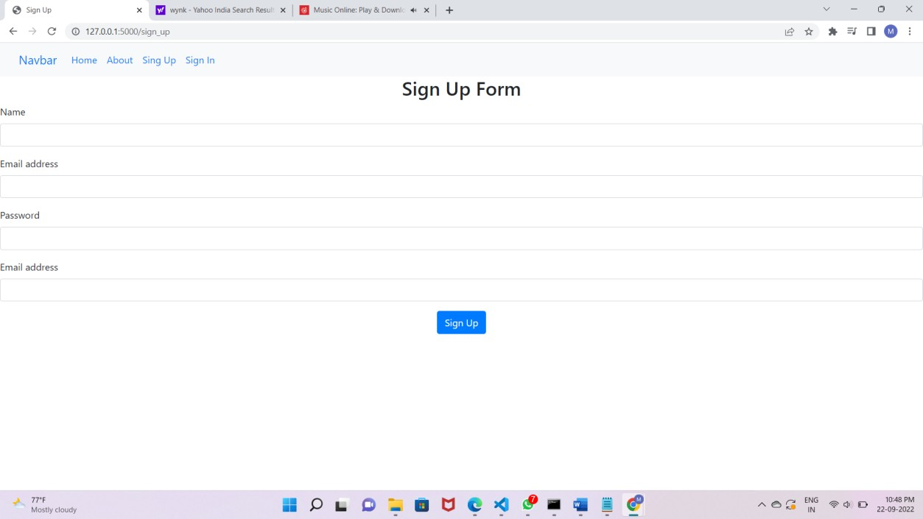

**Sign_in.html:**

{%extends'base.html'%}

{%blockhead%}

<title>SignIn</title>

{%endblock%}

{%blockbody%}

<center><h2>SignInPage</h2></center>

<form>

<divclass="mb-3">

<labelfor="email"class="form-label">Emailaddress</label>

<inputtype="email"class="form-control"id="email">

</div>

<divclass="mb-3">

<labelfor="pwd"class="form-label">Password</label>

<inputtype="password"class="form-control"id="pwd">

</div>

<center><button type="submit" class="btn btn-primary">SignUp</button></center>

</form>

{%endblock%}

## Output:

